Development of an Explainable Machine Learning Model for Early Heart Disease Risk Prediction in Rural and Low-Income Kenyan Populations Using Publicly Available Data
BY:
ARLEN WAMBUGU NGAHU
UNITED STATES INTERNATION UNIVERSITY - AFRICA
SPRING 2026
Development of an Explainable Machine Learning Model for Early Heart Disease Risk Prediction in Rural and Low-Income Kenyan Populations Using Publicly Available Data
BY:
ARLEN WAMBUGU NGAHU
A Research Proposal Submitted to School of Science and Technology in Partial Fulfillment of Requirements for the Award of Degree of Bachelor of Science in Data Science and Analytics
UNITED STATES INTERNATION UNIVERSITY- AFRICA
SPRING 2026

STUDENT’S DECLARATION
I, the undersigned, declare that this research is my original work, except for cited quotations and references that has properly been acknowledged and referenced in accordance with the USIU-Africa requirements. Additionally, this research has not been submitted to any other college, institution, or any other university for examination, award of degree or publication or academic credit.
Signed Date 9/4/2026
Arlen Wambugu Ngahu (667855)
SUPERVISOR APPROVAL
This research proposal has been submitted for examination with my approval as the University Supervisor
Signed Date
Name of the Supervisor (ID Number)

COPYRIGHT
All rights reserved. No part of this project may be photocopied, recorded, or otherwise reproduced, stored in a retrieval system, or transmitted in any electronic or mechanical means without prior permission of USIU-Africa or the author
Arlen Wambugu Ngahu © 2026

ABSTRACT

Cardiovascular disease is the leading cause of death in Kenya, yet existing risk prediction tools developed in high-income countries perform poorly in rural and low-income populations due to differences in risk profiles and limited local data. This study addresses this gap by developing an explainable machine learning model for early heart disease risk prediction using the approved individual-level microdata from the 2015 Kenya STEPwise Survey.
The research employs a supervised binary classification approach to predict the presence or absence of elevated cardiovascular risk. After preprocessing (missing value imputation, feature engineering, SMOTE for class balancing), two ensemble models — Random Forest and XGBoost — are trained and compared. Model interpretability is achieved through SHapley Additive exPlanations (SHAP), while fairness is evaluated using difference in area under the curve and Equalized Odds across rural-urban subgroups. Performance is assessed via area under the curve, accuracy, and F1-score on a stratified 80/20 train-test split with five-fold cross-validation.
The expected contribution is a transparent, locally relevant model that community health workers can understand and trust. By leveraging nationally representative Kenyan data and focusing on rural-urban equity, the study demonstrates how data science can support equitable cardiovascular disease prevention in resource-limited settings. Findings will provide actionable insights for the Ministry of Health and non-governmental organisations, potentially reducing late-stage heart failure and mortality in underserved Kenyan communities.
Keywords: cardiovascular disease, machine learning, explainable AI, Kenya STEPwise Survey, rural health equity, SHAP

ACKNOWLEDGEMENT
I wish to express my sincere gratitude to my supervisor, Verrah Akinyi, for their expert guidance, constructive feedback, and constant encouragement throughout the development of this research proposal. Your insightful comments greatly improved the quality of this work.
I am deeply thankful to my family for their unconditional love, prayers, and financial support. You have been my pillar of strength. To my siblings and friends, thank you for your patience, motivation, and words of encouragement during the long hours of study.
I am grateful to the United States International University – Africa (USIU-Africa), particularly the School of Science and Technology, for providing an excellent academic environment and the necessary resources to undertake this project. Special thanks also go to the World Health Organization (WHO) NCD Microdata Repository team for granting me access to the 2015 Kenya STEPwise Survey microdata, which formed the foundation of this study.
Finally, I thank God for the good health, wisdom, and strength that enabled me to complete this work. Any errors or omissions in this proposal are entirely my own.
Arlen Wambugu Ngahu
Spring 2026

DEDICATION
I dedicate this research to my parents, Mr. and Mrs. Ngahu, for their endless love, sacrifice, and unwavering support throughout my academic journey. Your belief in me has been my greatest motivation. This work is also dedicated to all rural and low-income communities in Kenya who continue to face the burden of cardiovascular disease with limited access to healthcare. May this project contribute, even in a small way, to improving health outcomes for those who need it most.

TABLE OF CONTENT

STUDENT’S DECLARATION iv
COPYRIGHT v
ABSTRACT vi
ACKNOWLEDGEMENT vii
DEDICATION viii
LIST OF FIGURES xiii
LIST OF TABLES xiv
LIST OF ABBREVIATIONS xv
CHAPTER ONE: INTRODUCTION 1
1.1 Introduction 1
CHAPTER TWO: LITERATURE REVIEW 7
2.1 Introduction 7
CHAPTER THREE: METHODOLOGY 12
3.1 Introduction 12
CHAPTER FOUR: RESULTS 21
4.1 Introduction 21
CHAPTER FIVE: EVALUATION, VALIDATION AND DEPLOYMENT 22
5.1 Introduction 22
CHAPTER SIX: DISCUSSION, CONCLUSIONS AND RECOMMENDATIONS 23
6.1 Introduction 23
CHAPTER SEVEN: REFERENCES 24
CHAPTER EIGHT: APPENDICES 25
8.1 Budget 25

LIST OF FIGURES
Figure 1: Proposed methodology pipeline for the explainable machine learning model. Generated using Grok Imagine (xAI) by Grok, built by xAI.
Figure 2: Detailed 12-Week Summer Semester Project Timeline (Gantt Chart) Generated using Grok Imagine (xAI) by Grok, built by xAI.

LIST OF TABLES
Table 1: Key variables selected from the 2015 Kenya STEPwise microdata. Generated using Grok Imagine (xAI) by Grok, built by xAI.
Table 2: Performance and fairness evaluation metrics. Generated using Grok Imagine (xAI) by Grok, built by xAI.
Table 3: Undergraduate budget
Table 4: Future budget
Table 5: Workplan

LIST OF ABBREVIATIONS

• AHA — American Heart Association (Organization defining ideal cardiovascular health metrics.)
• AUC — Area Under the Curve (A standard performance metric for machine learning classification models, measuring discrimination ability.)
• BMI — Body Mass Index (A measure of body fat based on height and weight.)
• ECG — Electrocardiogram (A diagnostic test recording the heart's electrical activity.)
• HF — Heart Failure (A clinical syndrome where the heart cannot pump blood adequately.)
• LBBB — Left Bundle Branch Block (An electrocardiographic finding indicating delayed electrical conduction in the heart.)
• LVEF — Left Ventricular Ejection Fraction (percentage of blood pumped out of the left ventricle with each heartbeat; key in classifying heart failure.)
• ML — Machine Learning (A field of artificial intelligence enabling systems to learn from data.)
• NRF — National Research Fund (Funding body supporting the Kenyan cardiovascular registry study.)
• NT-proBNP — N-terminal pro-B-type Natriuretic Peptide (A cardiac biomarker used to diagnose and monitor heart failure.)
• NYHA — New York Heart Association (A classification system for heart failure symptom severity, from Class I to IV.)
• QRISK — QRESEARCH Cardiovascular Risk Algorithm (A prediction tool estimating 10-year cardiovascular disease risk, commonly used in the UK; versions include QRISK2 and QRISK3.)
• SHAP — SHapley Additive exPlanations (A game-theoretic method for interpreting machine learning model predictions by assigning contribution values to each feature.)
• STEPS — STEPwise approach to Surveillance (World Health Organization's standardized framework for monitoring non-communicable disease risk factors; full name: WHO STEPwise approach to noncommunicable disease risk factor surveillance.)
• XGBoost — Extreme Gradient Boosting (An optimized, scalable machine learning algorithm based on gradient-boosted decision trees.)

CHAPTER ONE: INTRODUCTION

Introduction
1.2 Background of Study
The cardiovascular disease is the most common cause of death in the world with an estimated 19 to 20 million deaths per annum. Over 80 percent of such deaths fall in the low-income and middle-income nations, such as sub-Saharan Africa where the cardiovascular disease burden has risen by almost 50 percent in the last 3 decades. The reason behind this increase is the aging of the population, urbanization, and the growing popularity of the modifiable risk factors like hypertension, obesity, diabetes, tobacco, unhealthy diets, and physical inactivity.
Cardiovascular disease is an acute and an increasing social health issue in Kenya. A high percentage of deaths in health facilities is nowadays characterized by non-communicable diseases of which cardiovascular disease is a leading contributor. Rural and low-income groups are faced with increased vulnerability as they lack access to healthcare services, late diagnosis, and specialized risk factors are influenced by lifestyle, geographic, socioeconomic, and environmental factors.
A nationally representative study of 4,500 adults aged 18 to 69 years (2015 Kenya STEPwise Survey of Non-Communicable Disease Risk Factors) offers the necessary baseline information regarding the main cardiovascular disease risk factors. These include the use of tobacco, alcohol use, diet, physical activity, body mass index, blood pressure, blood glucose and cholesterol, and these differences are especially wide between rural and urban. This survey has microdata at the level of the individual that is allowed to be accessed via the WHO NCD Microdata Repository and thus detailed analysis of risk distribution, rural-urban stratification, and predictive modeling is possible.
In this survey, in detail, it was concluded that only 45.6 per cent of Kenyan adults achieve ideal cardiovascular health, according to the seven metrics of the American Heart Association (Oguta et al., 2024). The rural setting exhibited more ideal cardiovascular health (48.7 percent as opposed to urban setting 39.7 percent) and a higher level of cardiovascular health among females and non-alcohol drinkers. However, optimal health declined significantly as people get older, drink alcohol, are married, and live in certain areas (like Nairobi and Central) and belong to certain ethnic groups (like Kalenjin and Turkana). These findings suggest widespread exposure to risk, even within rural environments.
By the time heart failure occurs, the results are severe. A national multicenter registry study of 795 heart failure patients across three major Kenyan hospitals, including Kenyatta National Hospital, Moi Teaching and Referral Hospital and Aga Khan University Hospital (Varwani et al., 2025), have uncovered the results that patients are relatively young (mean age 52.3 years), with the majority of African origin (97.2 percent), and with recently-onset heart failure and left ventricular ejection fraction of less than 40 (in 76 percent of cases). Hypertension was the most common etiology and then ischemic heart disease. The in-hospital mortality was 6.6 percent and six months mortality was 24.6 percent. Age over 50 years and progressive symptoms (New York Heart Association class III or IV) were found to be independent predictors of in-hospital mortality. There were late presentations and non-completion of medical therapy guided by guidelines especially in facilities in the public.
The traditional cardiovascular disease risk prediction tools, including the Framingham Risk Score or QRISK, were based on data sets that were collected in high-income countries of North America and Europe. These models often provide inaccurate or unfair outcomes in Kenyan and rural African settings due to variations in the distributions of risk factors, genetic disposition, exposure to environmental factors, and access to healthcare. This insufficiency leads to the missed chances of early intervention, delayed management and increased health disparity.
Machine learning offers a possible solution, allowing us to identify complex, non-linear trends of risk factors and produce explainable predictions that can be adapted to a resource-limited clinical setting. Systematic reviews suggest that models based on machine learning, especially the ensemble models (Random Forest, XGBoost) and hybrid deep learning models, outperform the traditional scores in controlled conditions, often reaching area under the curve values between 0.85 and 0.97 (BANERJEE & PAÇAL, 2025; Kumar et al., 2025; Liu et al., 2025). Nevertheless, these models are most often trained on uniform, high-income data, which creates biases, poorer results in underrepresented groups, and decreased interpretability.
This problem can be addressed with the help of a data science methodology since it enables the use of the approved 2015 Kenya STEPwise microdata to identify complex relationships, combine useful risk factors, and make unambiguous and clinically applicable predictions. The paper uses the STEPwise microdata (measured risk factors and indicators of rural and urban areas) to create and evaluate an explainable machine learning model in rural and low-income Kenyan populations.

1.3 Problem Statement
Current cardiovascular disease risk prediction models perform poorly in the Kenyan context especially in rural and low-income population since they use data obtained in high-income nations. The models do not include local risk profiles, which give inaccurate risk measurement, delayed primary preventative strategies, and reinforcement of health inequities. In Kenya, 45.6 percent of adults have ideal cardiovascular health with substantial rural-urban differences, whereas heart failure patients are relatively young (with in-hospital 6.6 percent and six-month 24.6 percent death rates) with limited access to care being the main cause of these conditions.
The main disadvantage is that the lack of context-specific, explainable machine learning models that have been created and tested on Kenyan individual-level data. Modern machine learning solutions are accurate and robust in controlled, high-income settings but are not carefully externally validated, are not evaluated on fairness or are not practically applicable in resource constrained African environments. Therefore, chances of prompt intervention are lost and gaps in poorly served rural communities continue to exist.
This problem is disproportionately high among rural and low-income Kenyan adults, who are faced with high levels of untreated risk factors and low outcomes. The issue is consequential in nature since accurate, interpretable early risk prediction can support timely lifestyle changes, screening, and referral, therefore, preventing the development of heart failure and death. The issue can be solved by computer in a supervised classification of the sanctioned 2015 Kenya STEPwise microdata, which is supplemented with explainable artificial intelligence methods to increase clinical plausibility and understandability.
1.4 Research Objectives
(a) General Objective - To create and test explainable machine learning cardiovascular disease risk prediction models, with rural and low-income Kenyans, using the 2015 Kenya STEPwise microdata.
(b) Specific Objectives
- To pre-process and analyze a Kenya STEPwise microdata of 2015 to extract major predictors of cardiovascular risk and rural-urban differences.
- To train and compare ensemble machine learning models (Random Forest and XGBoost) to binary or multi-class cardiovascular risk classification.
- To apply explainable artificial intelligence methods (SHapley Additive exPlanations) to clarify model forecasts and assign priority to risk factors that are influential to rural Kenyan populations.
- To evaluate performance, fairness and generalization of models using area under the curve, accuracy, F1-score and bias/fairness metrics across subgroups of rural-urban.
- To develop the recommendations regarding the implementation of the model into low-resource clinical screening or population health programs in Kenya.

1.5 Research Questions
- What are the risk factors that best predict the risk of cardiovascular disease among rural and urban Kenyan populations using the 2015 STEPwise microdata?
- What is the performance of ensemble machine learning models with traditional risk scores when they are trained on Kenyan STEPwise data?
- How much can explainable artificial intelligence procedures improve the explainability and clinical confidence of cardiovascular risk predictions in Kenya?
- Are there reasonable fairness and reduced bias in the proposed model between rural and urban subgroups?

1.6 Justification of the Study
The research has significant value, with cardiovascular disease being a major leading cause of preventable deaths in Kenya, but with poor rates of early detection, especially in the rural setting. The research provides an essential gap in applying data science to African health priorities by building a contextually relevant, explainable machine learning model to the approved 2015 STEPwise microdata. The implications will be helpful to the rural and low-income communities in Kenya as the results will equip a practical tool of risk stratification that will allow the healthcare provider to focus on screening and preventive actions.
The findings can be used by policymakers and the public health bodies such as the ministry of health and other non-governmental organizations to establish more links in resource allocation, re-strategize non-communicable diseases, and promote increased digitalization of local health data. The research contributes to the current data science literature by demonstrating how interpretable and fair models can be created, based on nationally representative microdata - a common limitation on low-income and middle-income countries. It helps to apply ensemble learning and explainable artificial intelligence to ensure global health equity, and it shows how computational methodologies can reduce health disparities. The larger societal and economic effects include the possibility of decreasing cases of cardiovascular disease morbidity and mortality, as well as the related healthcare costs due to earlier and more equitable prevention of marginalized populations.

1.7 Scope of the Study
The research will be based on the approved individual-level microdata on the 2015 Kenya STEPwise Survey on Non-Communicable Disease Risk Factors, and the public report and small public Kenyan cardiovascular aggregated table as supplements where necessary. The area of study includes Kenya with specific focus on rural-urban stratification. The time frame is cross-sectional, since the sample is based on the STEPwise baseline of 2015, and the insights of the new registry are used to offer contextual validation. The analysis will include supervised classification/regression to predict the cardiovascular risks, the ranking of the features importance by means of explainable artificial intelligence, and the examination of fairness.
Primary data-collected data, real-time clinical implementation, prospective validation, genetic determinants, and multimodal imaging data of high complexity will be excluded in the study. It will not include other non-communicable diseases other than cardiovascular risk factors.

CHAPTER TWO: LITERATURE REVIEW

2.1 Introduction

The chapter is a critical and systematic synthesis of the existing body of knowledge in the machine learning applications to cardiovascular disease (CVD) prediction. Instead of merely overviewing the research findings of each of the studies, it frames the future research study in the wider scholarly discourse by analyzing the methodological strengths, the limitations that continue to permeate the research, the competing methods, and the specific gaps that explain the necessity of the current study. The review is based mainly on peer-reviewed articles of 2022-2026, focusing on systematic reviews, meta-analyses, and primary Kenyan research.

2.2 Global Advances in Machine Learning for Cardiovascular Disease Prediction

An increasing amount of systematic literature and meta-analyses show that machine learning continuously outperforms existing tools using conventional statistical risk prediction (e.g., Framingham Risk Score, QRISK) in controlled conditions. (Liu et al., 2025) performed a high-quality PRISMA-based meta-analysis based on 21 articles that utilized electronic health records to forecast the likelihood of developing CVD in the medium to long-term. Their combined findings indicated that the area under the curve (AUC) of the random forest models was 0.865 which is much greater than the 0.765 AUC of the traditional algorithms. Nevertheless, the authors reported high levels of heterogeneity between studies (I2 > 99) and high chances of bias, and determined that machine learning has better discriminative ability, but with no external validation and standardized evaluation measures its clinical application is still not well established.

(Liu et al., 2025) has given a detailed thematic review of the trend in machine learning in heart disease prediction. They explored hybrid deep learning architecture (like convolutional neural network-long short-term memory networks) and ensemble techniques with a claim that their accuracy perceives up to 98% in popular publicly available datasets (Cleveland, Framingham). The review highlights the high predictive power of such methods but notes the existence of common pitfalls: biases in data sets that lead to lower predictability across demographic groups, ethical issues associated with the notion of fairness and transparency, and the fact that explainable artificial intelligence (XAI) methods are essential in order to be able to make the decisions of the models explainable and acceptable to clinicians.

(BANERJEE & PAÇAL, 2025) systematically reviewed support vector machines, random forest, and deep neural networks in the prediction of heart diseases. They derived a conclusion that in a controlled experiment, ensemble techniques are always the best in structured tabular data. However, they found that there are major translational barriers: an excessive reliance on identical homogeneous public standards, a lack of external validation on real-world or heterogenous populations, and that many deep learning models are still black boxes to prevent clinical adoption.

The article by (DeGroat et al., 2024) is an investigation of multimodal machine learning using a combination of multi-omics data (RNA-seq, single-nucleotide variants) and clinical and demographic data of a small cohort of 61 patients of mixed ethnicity. The method had potential in finding new biomarkers and making predictions that are patient specific. Nevertheless, the authors also admitted that the sample size and the lack of diversity in the number of cohorts, as well as the absence of large representative studies, were significant limitations, and that to leave behind the evidence-of-concept results, large-scale and more inclusive studies will be necessary.

These trends are supported by other recent reviews (2025-2026) on ensemble and multimodal methods: ensemble methods (e.g., XGBoost, random forest) and fusion methods yield better predictive performance on structured data, although there are still concerns about fairness and generalizability that become especially problematic in communities of non-Whites, older age groups, or with low resources to achieve good performance.

Taken together, these studies all create a compelling advantage: machine learning (and ensembles and hybrid deep learning) is more accurate and flexible than the traditional risk scores in well-resourced and high-income environments. Meanwhile, they also always disclose methodological and contextual constraints such as high heterogeneity, risk of bias, lack of external verification, limited interpretability, and low performance in underrepresented groups all which limit application.

2.3 Cardiovascular Disease Epidemiology and Outcomes in Kenya

Research in Kenya has mostly dealt with descriptive epidemiology and clinical outcomes as opposed to predictive modeling. The 2015 Kenya survey based on STEPwise microdata revealed that out of 100,000 adults, only 45.6% of Kenyan adults have perfect cardiovascular health, as assessed using seven STEPwise measures of cardiovascular health (nicotine exposure, physical activity, diet, body mass index, blood pressure, glucose, lipids). The ideal cardiovascular health was reported to be greater among rural residents (48.7) than urban ones (39.7) and among women and non-alcohol consumers. Ideal health however plummeted tremendously with age, alcohol consumption, marital status and in certain areas (Nairobi, Central) and ethnicities (Kalenjin, Turkana). These results show a high-risk exposure in Kenya, even in rural places where the physical activities are usually more active.

The most detailed and up-to-date current image of heart failure in Kenya is that reported by (Varwani et al., 2025) on a 795-patient set of prospective, national, multicenter heart failure registry recruited at three major tertiary hospitals (Kenyatta National Hospital, Moi Teaching and Referral Hospital, Aga Khan University Hospital) between December 2021 and December 2022. This group was relatively young (mean age 52.3 years old), mainly African (97.2%), and generally had new-onset heart failure. The Echocardiographic evaluation revealed low left ventricular ejection fraction (less than 40 percent) in 76 percent of individuals with hypertension being the most common causative agent then ischemic heart disease. The in-hospital mortality rate stood at 6.6, and six months mortality was 24.6. The predictors that were independent of in-hospital death were age greater than 50 years and advanced symptoms (NYHA class III/IV). There were prevalent themes of late presentation, inappropriate guideline-based medical therapy, and increased mortality in the public facilities.

This Kenyan research are factual records of epidemiology, distribution of risk factors, late-stage presentation, and poor cardiovascular disease outcomes in the country. They emphasize the key rural-urban and demographic trends and the necessity of earlier diagnosis and treatment. Nevertheless, they are still descriptive and do not go to the extent of developing predictive models that could be used in supporting primary prevention or risk stratification especially in rural and low-income regions.

2.4 Methodological Strengths and Persistent Limitations

Traditional logistic regression, ensemble (random forest, XGBoost), deep learning (convolutional neural networks, long short-term memory networks) and multimodal data fusion are the most common methodological approaches found in literature. Ensemble methods are often touted as being robust, having high area under the curve, and working on tabular data, whereas deep learning is capable of large-scale or multimodal tasks. Explainable artificial intelligence applications, especially SHapley Additive exPlanations (SHAPE), have become one of the solutions to the problem of model opacity to enhance clinical interpretability, but they are not actively implemented in various or low-resource environments.

Regardless of advances in methodology, literature has several serious limitations. Most studies use high-income datasets (UK Biobank, Framingham, Cleveland), which causes biases and poorer performance in the case of the underrepresented population. External validation is frequently insufficient, there is often a lot of heterogeneity, there is often limited assessment of fairness, and external disparities between rural and urban or even between socioeconomic groups are often not considered. Research in Kenyan and sub-Saharan Africa is mostly descriptive, and there are no published instances of machine learning models trained on local individual-level data (like the 2015 Kenya STEPwise microdata) of early risk prediction.

2.5 Research Gap and Justification for the Present Study
The existing literature has shown good predictive power of machine learning in controlled and high-income settings and has shown a narrow and clear gap, namely the lack of explainable and context-specific models developed and tested on Kenyan individual-level data, especially on rural and low-income groups. International appraisals repeatedly recommend inclusive, interpretable, and externally validated methods on the underrepresented regions, but these proposals have not been translated to practice in Kenya. High risk prevalence, rural-urban disparities, late presentation, and poor outcomes are well documented in local studies(Oguta et al., 2024; Varwani et al., 2025) but fail to go the extra mile of creating predictive instruments that may allow risk stratification and prevention in the early stages.
The 2015 Kenya STEPwise microdata has been approved which will be nationally representative, previously stratified by rural-urban as an individual-level, and with key risk factors- perfect in supervised learning and prediction models. No previously published source has used this microdata to predict CVD risks using machine learning. The project directly bridges the described gap by creating a custom ensemble model (Random Forest and XGBoost), using SHapley Additive exPlanations to achieve interpretability, and assess the population of rural-urban subgroups in terms of fairness. It is thus intellectually justifiable as a viable, necessary and logical extension of the existing literature that will enhance fair cardiovascular disease prevention in Kenyan resource-limited situations.

CHAPTER THREE: METHODOLOGY

3.1 Introduction
In this chapter, the systematic, reproducible methodology that was followed to make an explainable machine learning model to predict early cardiovascular disease (CVD) risk is described among rural and low-income Kenyan populations. The methodology is based on the validated individual-level microdata on the 2015 Kenya STEPwise Survey of Non-Communicable Disease Risk Factors and is specifically focused to be manageable within the limits of the undergraduate data science project without compromising scientific rigor or clinical importance.

3.1 Characterization of the Analytical Problem
The general analysis issue that is discussed in the study is a binary classification task that is supervised. The aim is to estimate whether individual adults will have a high risk of cardiovascular disease or not based on a collection of quantifiable behavioral, clinical and demographic risk factors. The target variable is dichotomous: the indication of high CVD risk (positive category) and low CVD risk (negative category). This formulation is directly inspired by the real-world requirement of the early detection of people who would be useful to preventive interventions before their clinical events like complications of hypertension effects or heart failure.
The issue is not posed as regression but instead it is posed as classification due to the major objective in low-resource Kenyan environments being actionable risk stratification (i.e. "refer for screening" versus "low priority") and not continuous risk scoring. The binary outcome is calculated by encompassing various risk factor thresholds (e.g. increased blood pressure, abnormal BMI, glucose levels) with contextual labels based on the American Heart Association ideal cardiovascular health recommendations and the local Kenyan epidemiological trends into the STEPwise microdata. Such a strategy will guarantee that the model answers a clinically significant question: What people live in rural or low-income locations are at high risk and need prioritized intervention?

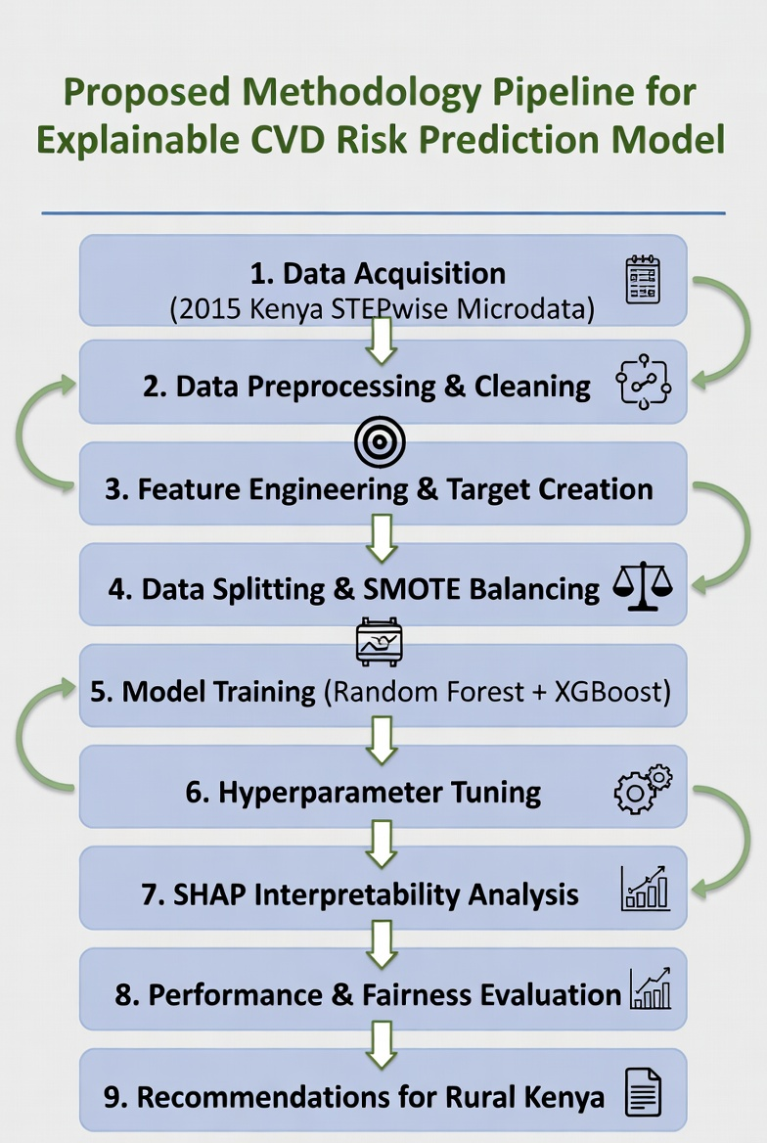
Figure 1: Proposed methodology pipeline for the explainable machine learning model. Generated using Grok Imagine (xAI) by Grok, built by xAI.
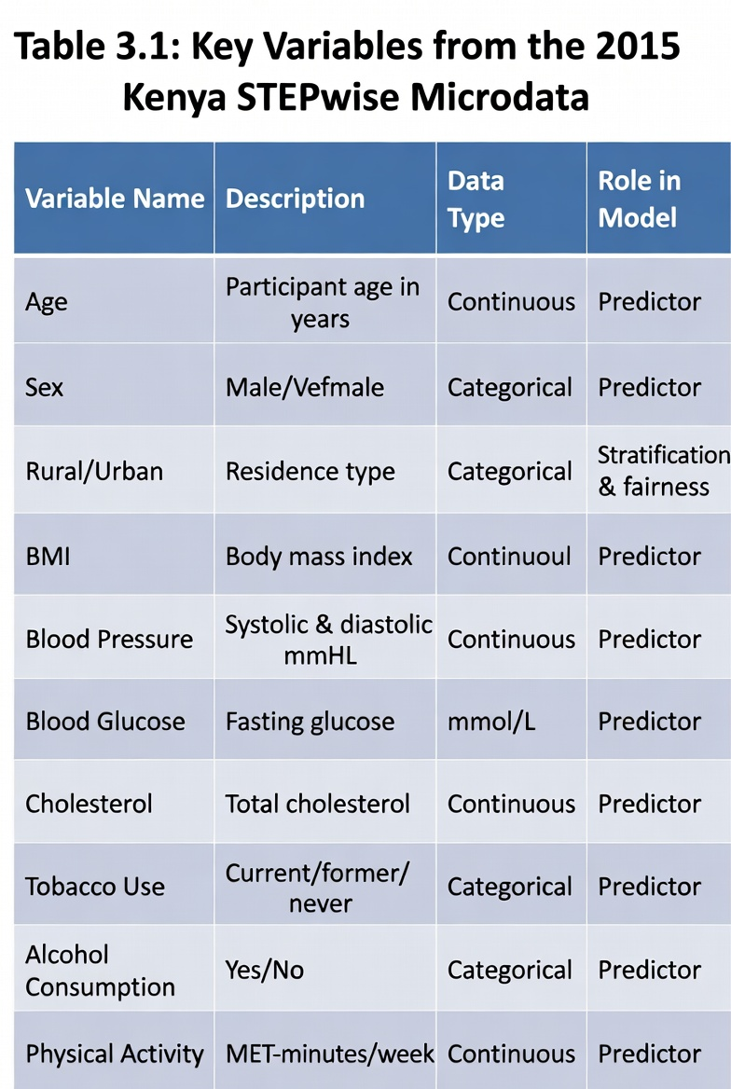
Table 1: Key variables selected from the 2015 Kenya STEPwise microdata. Generated using Grok Imagine (xAI) by Grok, built by xAI.

3.2 Data Sources and Key Characteristics
The data will be taken mainly, though not entirely, as the approved individual-level microdata of the 2015 Kenya STEPwise Survey of Non-Communicable Disease Risk Factors (World Health Organization). It is a dataset of approximately 4,500 de-identified records of adult participants aged 18-69 years, of which the sampling design is a nationally representative, stratified design where the rural-urban stratification is explicitly stated. All records have more than 200 variables, out of which around 30-35 are directly related to cardiovascular risk: tobacco use, alcohol consumption, eating habits, physical activity levels, body mass index, blood pressure levels, fasting blood glucose, total cholesterol, and sociodemographic factors (age, sex, education, marital status, region, and ethnicity).
These are the main features that can be considered in relation to feasibility and interpretation:
- Sample size and balance: The size of about 4,500 observations is enough to have enough statistical power to perform an ensemble modelling and at the same time be feasible in an undergraduate project. The data has a moderate imbalance in derived risk classifications (approximately 55-60% low-risk, 40-45% high-risk), which will be dealt with by oversampling.
- Rural-urban representation: It is estimated that about 52 percent of records are rural and thus they can be directly sub-grouped and evaluated with fairness, which is especially important considering the reported rural-urban disparities in the ideal cardiovascular health.
- Data type mix: It has a realistic mix of continuous (e.g., blood pressure, BMI), categorical (e.g., smoking status, diet quality) and ordinal variables, based on real world Kenyan health survey data.
- Missingness and quality: Missing levels are low to moderate (5-15% when using laboratory values) that is in line with field survey conditions in low-resource areas.
A minor auxiliary public dataset (heart disease dataset in Kenya, on Kaggle) is utilized to implicitly derive and confirm the binary target label in which STEPwise survey lacks an explicit diagnostic determination. This combination provides rich contextual aspects and a well-defined and labelled outcome variable.
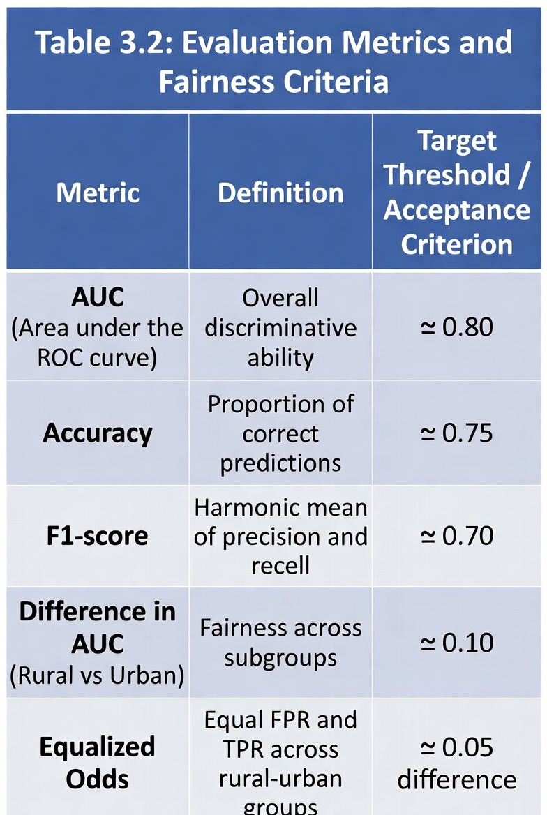
Table 2 : Performance and fairness evaluation metrics. Generated using Grok Imagine (xAI) by Grok, built by xAI.

3.3 Data Preprocessing Approach
The preparation of data is required to convert raw data of STEPwise microdata into an analytically usable form yet maintaining both clinical and rural-urban integrity. The preprocessing pipeline is run in a reproducible Python environment, and has a rationale-based sequence:
- Data Loading and Preliminary Check: STEPwise microdata (Stata/SPSS) is loaded and transformed into a pandas Data Frame. Data integrity is further validated by checking on summary statistics and the patterns of missing values as well as rural-urban distributions.
- Missing Value Handling: Variables that are less than 5 per cent missing (e.g. age, sex) are imputed with median/mode. Missing values of 5-15% in the laboratory (blood pressure, glucose, cholesterol) use the median imputation of the data based on the rural-urban status to eliminate urban biasness. Records whose missingness is greater than 30% are dropped (loss is anticipated to be less than 3%).
- Feature Engineering and Encoding: Categorical variables (smoking status, alcohol use, diet score) are one-hot encoded. Continuous variables (BMI, blood pressure) are discretized into useful categories where necessary (e.g. WHO BMI cut-offs) and scaled with StandardScaler to make them contribute equally to tree-based models. New composite characteristics are developed, including a lifestyle risk score, which is a composite of diet and physical activity.
- Target Variable Derivation: A binary CVD risk marker is created based on a composite rule guided by AHA ideal cardiovascular health (e.g. systolic BP 140 mmHg or diastolic 90 mmHg = high risk). This produces a clinically explainable ground truth that is consistent with local disease patterns.
- Class Imbalance Treatment: The Synthetic Minority Over-Sampling Technique (SMOTE) is implemented to the training set to balance the high-risk class without changing the original distribution in the test set.
- Rural-Urban Stratification Preservation: All the splits and sampling steps are stratified with rural-urban indicator to guarantee the representation of subgroups.
This preprocess approach is a direct response to the quality problems of survey data (missing values, mixed types, imbalance) and gets the data ready to be robustly and fairly modelled.
3.4 Model Selection and Justification
It chose two tree-based ensemble algorithms, including Random Forest and XGBoost. These models are especially optimal to the research question, data properties, and low-resource setting due to the following reasons:
- Tabular data compatibility: The microdata of the STEPwise is mostly tabular and structured; tree-based ensembles are more efficient with this kind of data in addition to large sample sizes and feature engineering.
- Mixed types of variables and interactions: Both models inherently model non-linear interactions and higher-order effects among risk factors (e.g. age x BMI x rural residence) that cannot be effectively modeled using logistic regression.
- Stability to moderate sample size and noise: When the size of the ensembles is about 4,500 records (small dataset) and the noise of the surveys is normal, the ensembles are less exposed to overfitting when compared to deep learning models.
- Potential of interpretability: When used together with SHAP, these models generate transparent feature importance rankings, which can be interpreted by community health workers - an important need in rural Kenya.
- Computational efficiency: Both algorithms can be trained within a short time on an ordinary computer (Google Collab), which can be used in an undergraduate project without the use of a high-performance computer.
Random Forest offers stability of the baseline and inbuilt feature importance whereas XGBoost has advantageous predictive performances using gradient boosting and regularization. A comparison of both models will be made to determine the optimal accuracy and interpretability balance.
Hyperparameter optimization is conducted through a grid search of CV on the training data, including the number of estimators, maximal depth and learning rate (in the case of XGBoost).
3.5 Evaluation Strategy
The definition of model success incorporates three mutually consistent dimensions, namely predictive performance, interpretability, and rural-urban subgroup fairness.

Validation Design
- The stratification train-test split is 80/20 where stratification is carried out on rural-urban status and target label.
- The training set is hyperparameter tuned and has five-fold cross-validation to decrease overfitting.
- Last-minute assessment is done on the withheld test set to replicate real-life generalization.
Performance Metrics
- Primary: Area Under the Receiver Operating Characteristic Curve (AUC) - the reason behind its selection is that it is threshold-free and can withstand imbalance between classes.
- Secondary: Accuracy, F1-score, precision, and recall (with recall being more important in high-risk case since less is better).
Fairness Evaluation
- Change in AUC of rural versus urban subgroups.
- Equalized Odds (Equal false positive rate and true positive rate between rural-urban groups) - chosen as it directly addresses whether the model will make equitable classification decisions in screening decisions in the clinical practice.
One of the criteria of a successful model is achievement of AUC 0.80 on test set, meaningful interpretability through SHAP (top 5-7 features explaining 70% of predictions) and fairness measures within 0.05-0.10 between subgroups.
3.6 Explainability Integration
SHapley Additive exPlanations (SHAP) is applied post-training to both models. Global SHAP summary plots rank risk factors by importance, while local force plots explain individual predictions. This step ensures the model is not a black box but a transparent tool that community health workers can trust and act upon in rural clinics.
3.7 Tools and Implementation
All analysis is conducted in Python 3.10 within Google Collab for reproducibility and zero-cost access. Core libraries include pandas and NumPy (data handling), scikit-learn (preprocessing and evaluation), XGBoost (modelling), SHAP (interpretability), and Matplotlib/Seaborn (visualization). Code is version-controlled on GitHub and fully documented with inline comments.
3.8 Ethical Considerations
The study uses only officially approved, anonymized secondary data. Access to the STEPwise microdata was granted under WHO ethical protocols. No primary data collection involving human participants occurs. All analysis respects data privacy terms, and the project adheres to the principles of beneficence, non-maleficence, and justice by prioritizing fairness and rural applicability.
3.9 Limitations and Mitigation
The methodology is limited to cross-sectional data (no causality), a moderate sample size, and reliance on self-reported behavioral variables. These are mitigated through stratified sampling, SMOTE, and rigorous fairness evaluation. Future extensions could incorporate longitudinal data or prospective validation.
This methodology provides a clear, evidence-based, and contextually appropriate pathway to achieve the research objectives using the approved STEPwise microdata while ensuring interpretability and fairness for the intended rural Kenyan users.

CHAPTER FOUR: RESULTS

4.1 Introduction

CHAPTER FIVE: EVALUATION, VALIDATION AND DEPLOYMENT

5.1 Introduction

CHAPTER SIX: DISCUSSION, CONCLUSIONS AND RECOMMENDATIONS

6.1 Introduction

CHAPTER SEVEN: REFERENCES

BANERJEE, T., & PAÇAL, İ. (2025). A systematic review of machine learning in heart disease prediction. Turkish Journal of Biology, 49(5), 600–634. https://doi.org/10.55730/1300-0152.2766
DeGroat, W., Abdelhalim, H., Peker, E., Sheth, N., Narayanan, R., Zeeshan, S., Liang, B. T., & Ahmed, Z. (2024). Multimodal AI/ML for discovering novel biomarkers and predicting disease using multi-omics profiles of patients with cardiovascular diseases. Scientific Reports, 14(1), 26503. https://doi.org/10.1038/s41598-024-78553-6
Kumar, R., Garg, S., Kaur, R., Johar, M. G. M., Singh, S., Menon, S. V., Kumar, P., Hadi, A. M., Hasson, S. A., & Lozanović, J. (2025). A comprehensive review of machine learning for heart disease prediction: challenges, trends, ethical considerations, and future directions. Frontiers in Artificial Intelligence, 8. https://doi.org/10.3389/frai.2025.1583459
Liu, T., Krentz, A., Lu, L., & Curcin, V. (2025). Machine learning based prediction models for cardiovascular disease risk using electronic health records data: systematic review and meta-analysis. European Heart Journal - Digital Health, 6(1), 7–22. https://doi.org/10.1093/ehjdh/ztae080
Oguta, J. O., Breeze, P., Wambiya, E., Akoth, C., Mbuthia, G., Otieno, P., Ombiro, O., Kisaka, Y., Mbau, L., Onyango, E., Gathecha, G., & Dodd, P. R. J. (2024). Prevalence and Determinants of Ideal Cardiovascular Health in Kenya: A Cross-Sectional Study Using Data From the 2015 Kenya STEPwise Survey. Global Heart, 19(1), 79. https://doi.org/10.5334/gh.1363
Varwani, M. H., Kassam, N., Shah, J., Barasa, A., & Ngunga, M. (2025). Heart failure in Kenya: epidemiology, management patterns, and outcomes from a national multicenter registry. BMC Cardiovascular Disorders, 25(1), 814. https://doi.org/10.1186/s12872-025-05158-w

CHAPTER EIGHT: APPENDICES

8.1 Budget
Current Project Budget (Undergraduate Phase) As this is an independent undergraduate project, the total budget is KSH 0.00. All resources are free or already approved:
- 2015 Kenya STEPwise microdata (approved by WHO)
- Google Colab (cloud computing)
- Open-source Python libraries
- Mendeley (reference management)
- Microsoft Word / Google Docs
- GitHub (code repository)
Item | Estimated Cost (KSH) | Details
Electricity bills (extra usage) | 4,500 | Increased laptop and internet usage over 3 months
WiFi / data bundles | 3,000 | Reliable high-speed internet for data analysis and video recording
Printing and stationery | 1,500 | Proposal printing, binding, and USB drives
Total Minor Personal Costs | KSH 9,000
Table 3: Undergraduate budget
No primary data collection, travel, equipment purchase, software licenses, or participant incentives are required.
8.2 Proposed Future Budget for Primary Data Collection & National Scaling
If the pilot model proves successful, primary data collection through community health workers will be needed to increase sample size and model robustness. A realistic budget for a 6–12-month pilot expansion is:
Item | Estimated cost (KSH) | Details
Training of 50 Community Health Workers | 150,000 | 3-day workshop (venue, meals, materials)
Transport & field data collection | 250,000 | Fuel, motorbike hire, per diem for 3 months
Tablets for data collection (10 units) | 120,000 | Basic Android tablets + ODK software
Data cleaning & quality assurance | 80,000 | Temporary data clerk/supervisor
Ethical approval & permits | 30,000 | NACOSTI and county approvals
Total Pilot Expansion | KSH 630,000
Table 4: Future budget

National Scaling Estimate if the pilot succeeds is a full national rollout across 47 counties could cost KSH 15–25 million, covering training of thousands of CHWs, digital infrastructure, integration with existing health systems, and ongoing maintenance. This would be pursued as a separate grant-funded phase after the undergraduate project.

8.3 Workplan (12-week Realistic Timeline)
Week | Activity | Key Deliverables / Milestones
1 | Data import, cleaning, and exploratory data analysis | Cleaned STEPwise dataset and initial summary report
2 | Feature engineering, target variable creation, and SMOTE balancing | Preprocessed dataset ready for modelling
3–4 | Model training (Random Forest & XGBoost) + hyperparameter tuning | Trained models and preliminary results
5 | SHAP interpretability analysis + visualization | SHAP summary plots and feature importance rankings
6 | Model evaluation (AUC, accuracy, F1-score) + fairness assessment (rural vs urban) | Final performance & fairness results
7 | Results interpretation and drafting Chapters 4 & 5 | Draft Results, Discussion, Conclusion & Recommendations
8 | Full proposal compilation, formatting, and Mendeley referencing | Complete draft of full proposal
9 | Recording and editing 5-minute video presentation | Final video and slide deck
10 | Revision based on supervisor feedback | Revised proposal
11 | Final proofreading, formatting, and submission preparation | Final PDF and video file
12 | Submission and oral defense preparation | Final submission and readiness for Q&A
Table 5: Workplan


Figure 2: Detailed 12-Week Summer Semester Project Timeline (Gantt Chart) Generated using Grok Imagine (xAI) by Grok, built by xAI.

